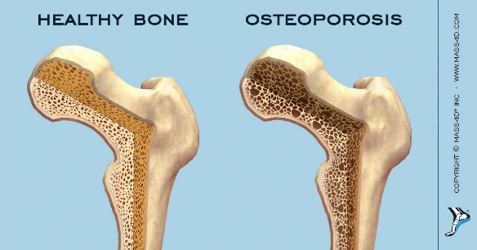

This file contains information on 500 women age 55 and above and any recent bone fractures they have experienced. The data comes from the Global Longitudinal study of Osteoporosis in Women (GLOW) project. This is your master data set. Variables included are:

* 1. FRACTURE: A binary variable indicating whether the subject has recently experienced the fracture of any bone. (1=yes)
  2. PRIORFRAC: A binary variable indicating whether the subject has experienced a prior bone fracture. (1=yes)
  3. AGE: A numerical variable showing the age of the subject. Ages range from 55 to 90.
  4. WEIGHT: A numerical variable showing the weight of the subject in pounds.
  5. HEIGHT: A numerical variable showing the height of the subject in inches.
  6. BMI: The Body Mass Index of the subject.
  7. MENOBY45: A binary variable indicating whether the subject experienced early menopause, i.e., by age 45.
  8. MOMFRAC: A binary variable indicating whether the subject’s mother experienced at least one bone fracture.
  9. ARMASSIST: A binary variable indicating whether the subject needs to “push up” with her arms to rise from a chair.